Name : Ashok Rathod

Lesson: SQL Server Development tool

Date: 4/6/19

Create Database

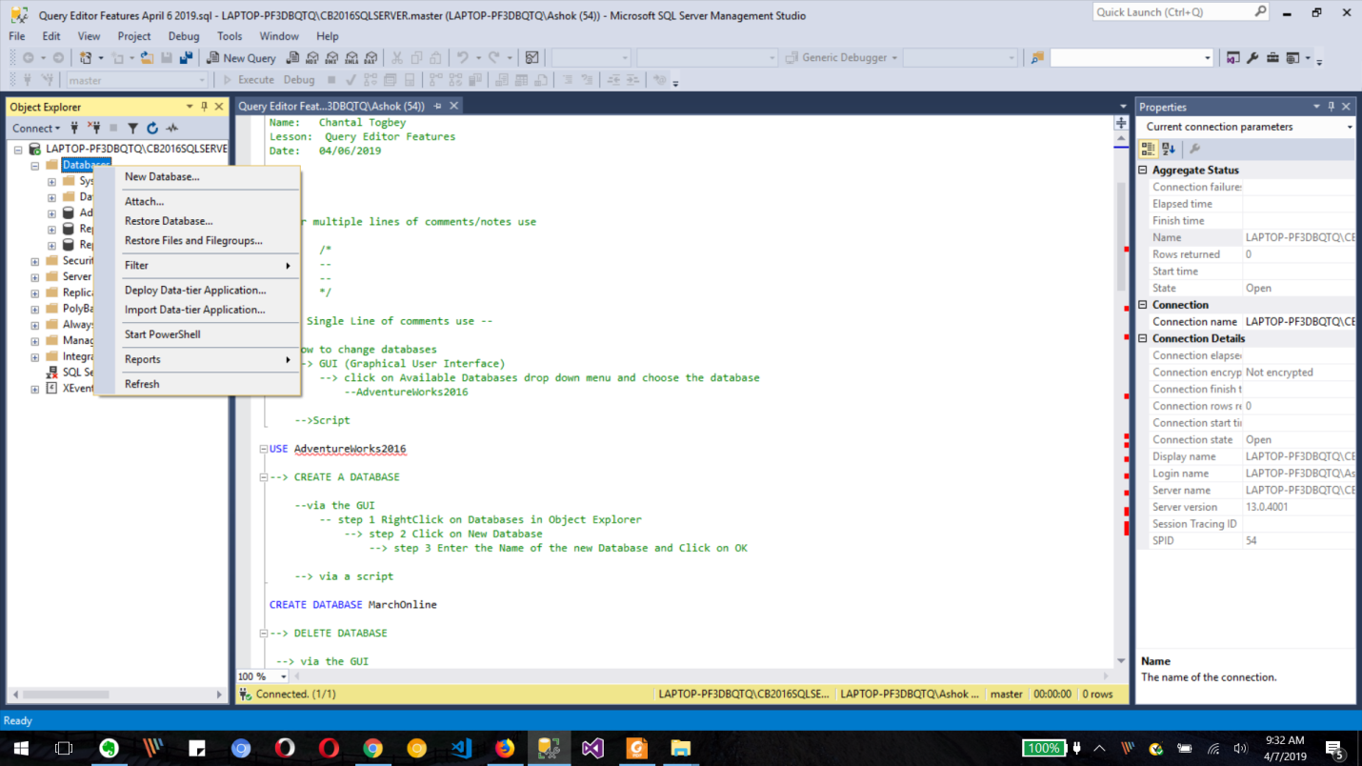

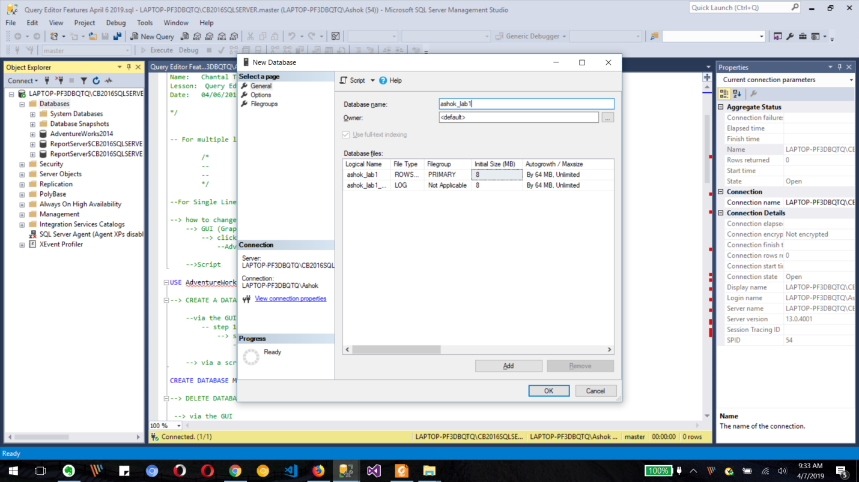

Create Table(emp) in created Database (Ashok_lab1)

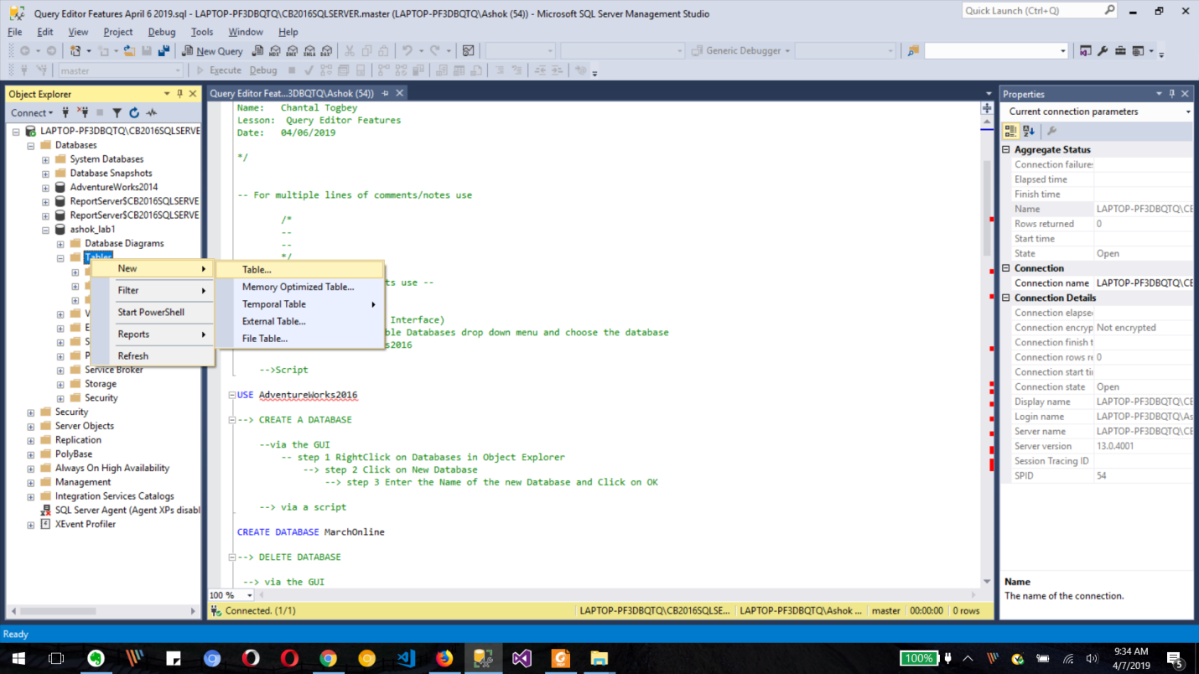

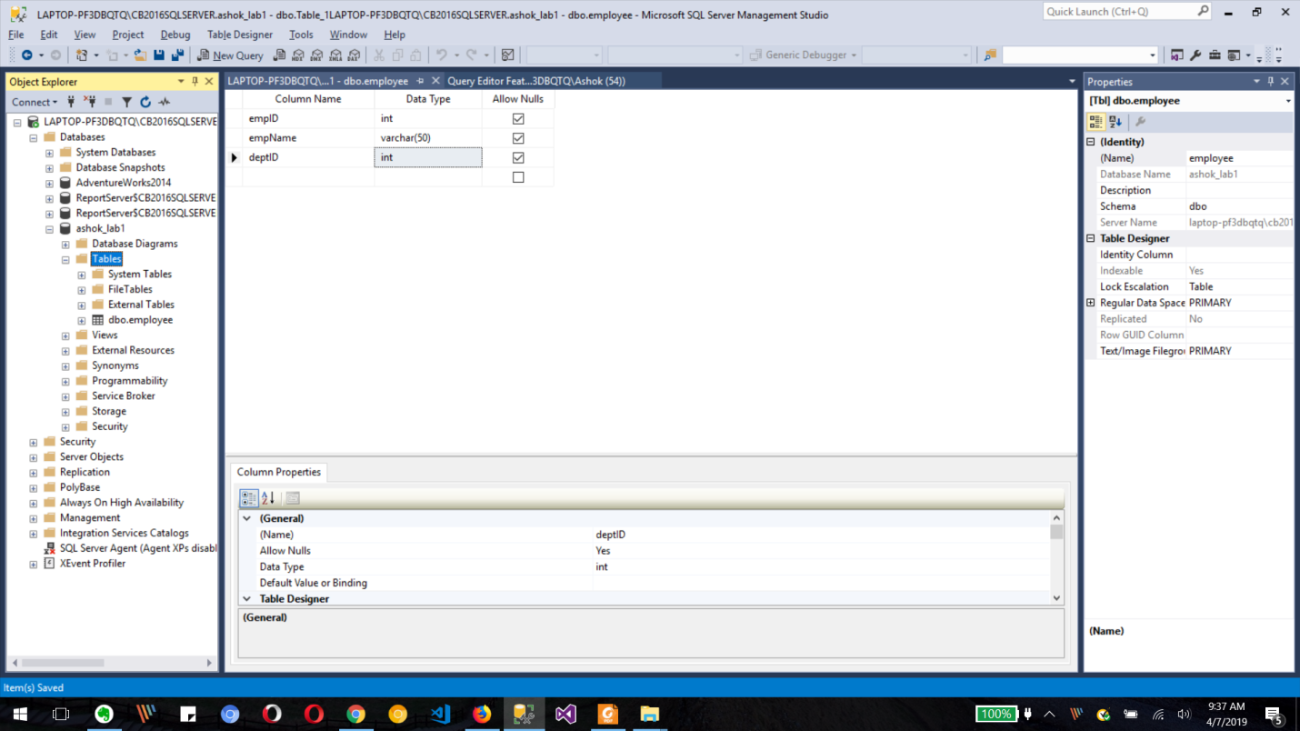

Dept table

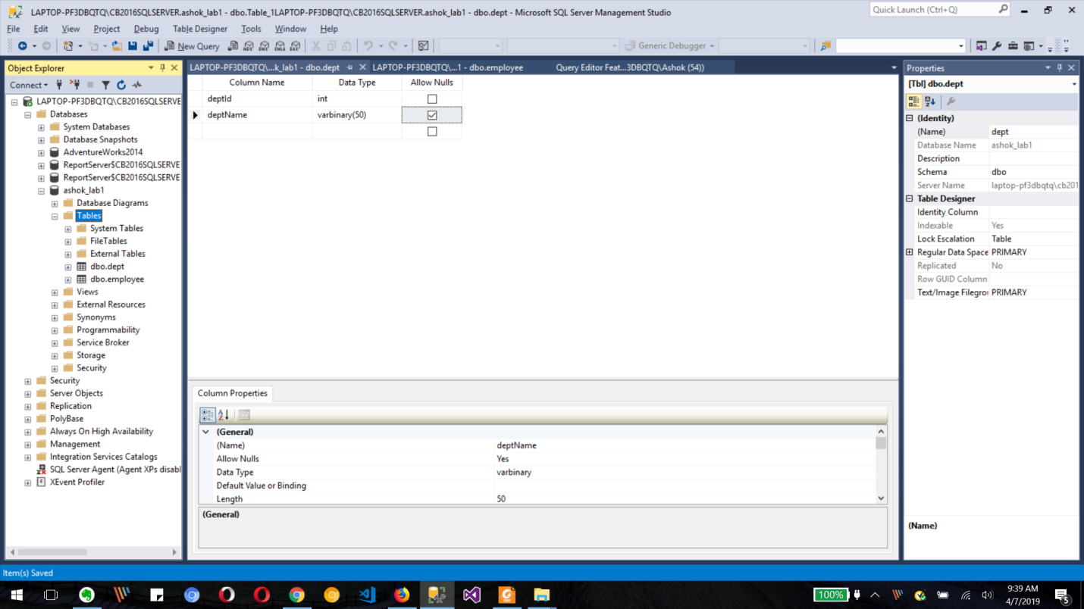

Delete both tables

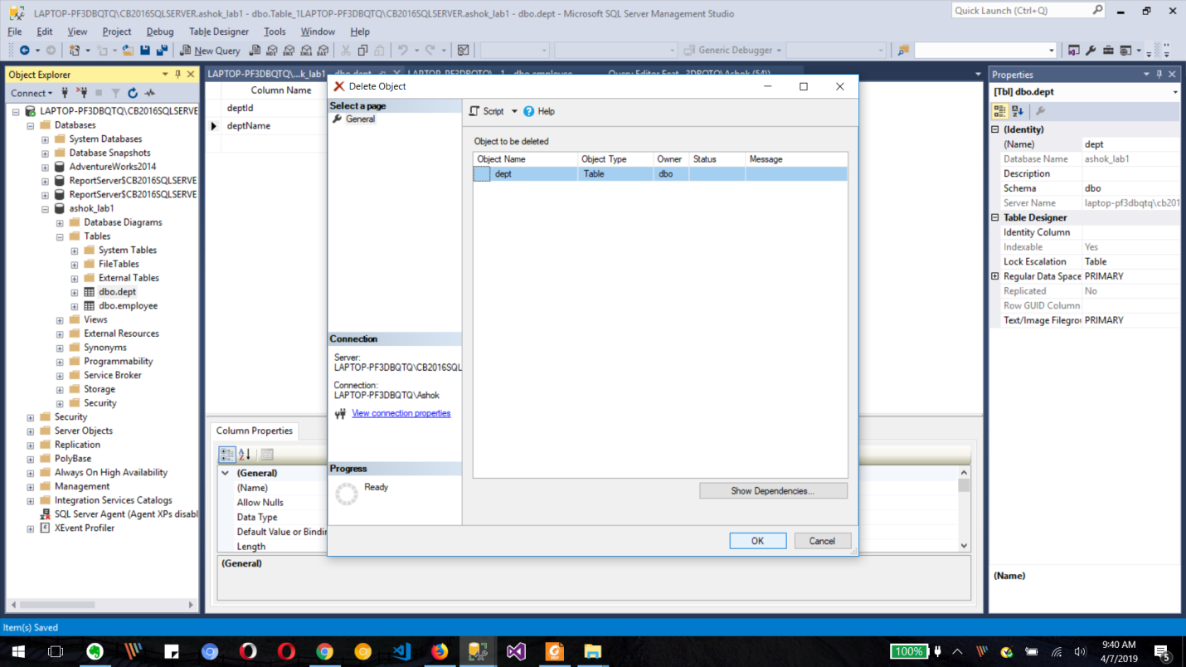

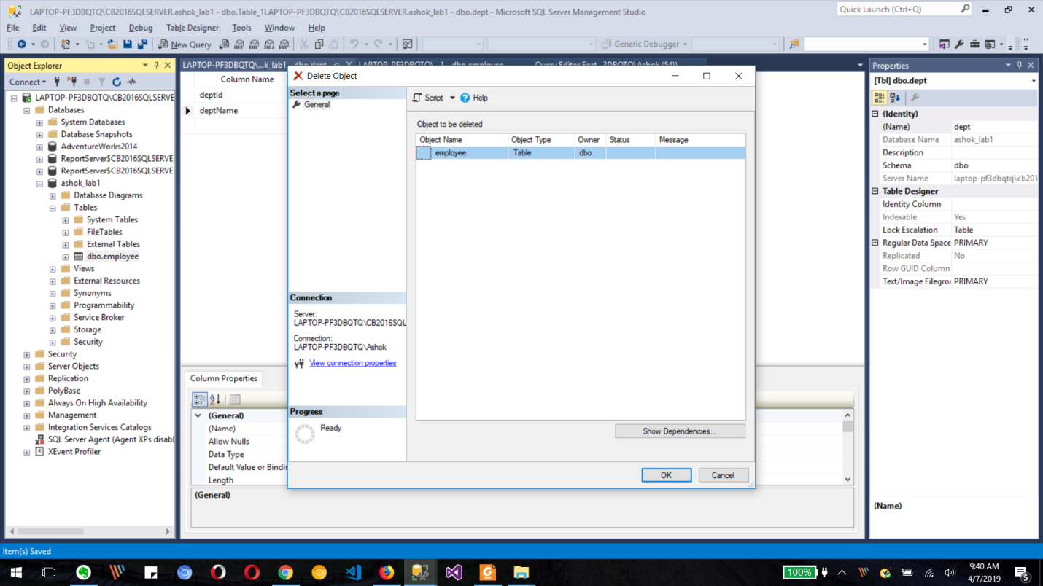

What is BI ?

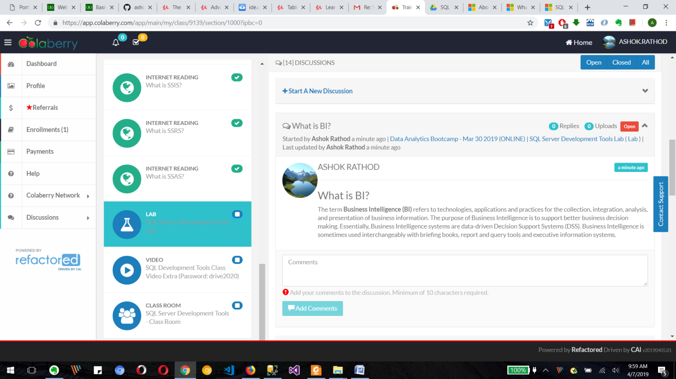

**Group Members**

[**Ashvi616@gmail.com**](mailto:Ashvi616@gmail.com) **Ashok Rathod**

[**lois.wanyoike@gmail.com**](mailto:lois.wanyoike@gmail.com) **Lois Wanyoike**

### [awah.divine@gmail.com](mailto:awah.divine@gmail.com) Awah Divine

### [dereje.dimetros@gmail.com](mailto:dereje.dimetros@gmail.com) Dereje Dimetros